What is research?

* Originality
* Knowledge gain and contribution to the field
* Understanding

Originality

Producing something that not been developed before.

Do something that has been done before but in a different approach

Knowledge and understanding

|  |
| --- |
| Knowledge  Represent your knowledge of why information given from data happens |
| Information  Represent data that have been processed to provide insight into their meaning. |
| Data  Elements that describe objects or event,can be raw text/number. |

Research Process

1. Identify the broad area of study
2. Select a research topic
3. Decide on an approach
4. Plan how you will perform the research
5. Gather data and information
6. Analyse and interpret these data
7. Present the results and findings

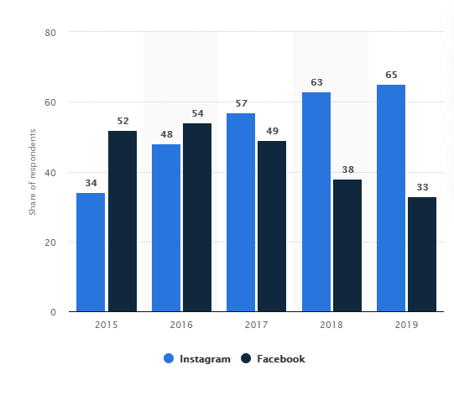

<https://www.statista.com/statistics/1021980/popular-social-media-platforms-used-for-art/>

Research Method:Case study indirectly:study of reports or documentation